PIZZA SALES SQL QUERRIES

A)KPI’S:
1. TOTAL REVENUE
select sum(total_price) as total_revenue from pizza_sales;
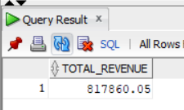

2. Average Order Value
select (sum(total_price)/ count(distinct order_id)) as Average_order_value
from pizza_sales;
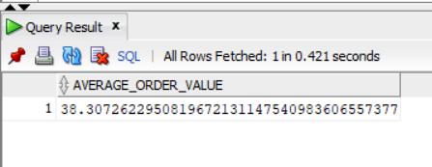
3. Total Pizza Sold
select sum(quantity) as total_pizzas_Sold from pizza_sales;
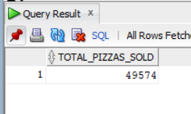

4. Total Orders
select count(distinct order_id) as total_orders from pizza_sales;
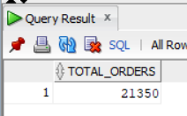
5.Average pizzas Per Order
select cast(sum(quantity)/(count(distinct order_id))as decimal (10,2)) as Avg_Pizzas_Per_Order
from pizza_sales;

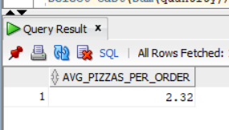

CHART REQUIREMENT
1.Daily Trend for Total Orders:
Select to_char(order_date,'Day') as order_day,count(distinct order_id) as Total_Orders
From pizza_sales
Group by to_char(order_date,'Day');
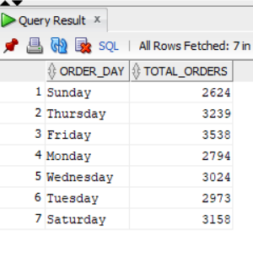

2.Monthly Trend For Total Orders:
Select to_char(order_date,'Month') as Month_Name, count(distinct order_id) As Total_Sales
From pizza_sales
Group by to_char(order_date,'Month')
order by Total_Sales DESC;

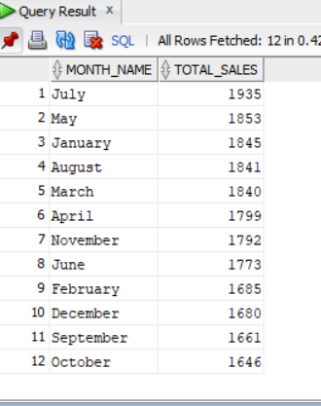

3.Percentage of Sales by Pizza Category:

select pizza_category,sum(total_price) as Tota_Sales,sum(total_price)*100/(select sum(total_price) from pizza_sales) as Perc_Total_Sales
from pizza_sales
group by pizza_category;
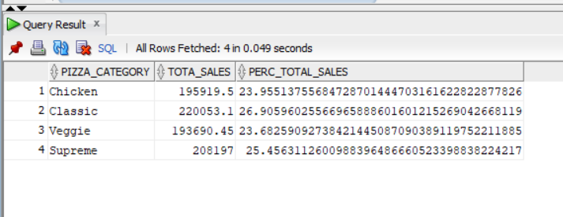
select pizza_category,sum(total_price) as Tota_Sales,sum(total_price)*100/(select sum(total_price) from pizza_sales) as Perc_Total_Sales
from pizza_sales
where month(order_date)=1
group by pizza_category;
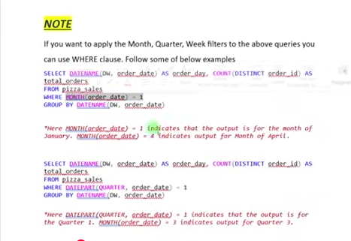
TO_CHAR(order_date,'MM')

4. Percentage of Sales by Pizza Size:
select pizza_size,sum(total_price) as Tota_Sales,
cast(sum(total_price)*100/
(select sum(total_price)
from pizza_sales) as decimal(10,2))as Perc_Total_Sales
from pizza_sales
group by pizza_size
order by Perc_Total_Sales desc;
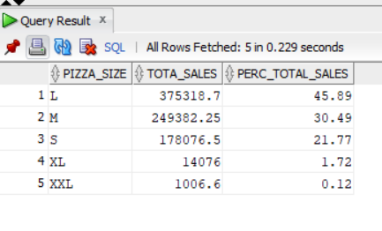
5.Total Pizzas sold by Pizza Category:

select pizza_category,sum(quantity) as Total_Quantity_Sold
from pizza_sales
where to_char(order_date,'MM')='02'
group by pizza_category
order by Total_Quantity_Sold desc;
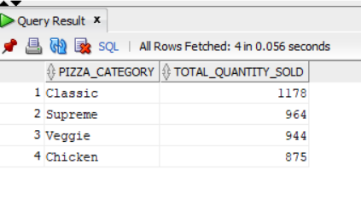
6.Top 5 Pizza by Revenue:

select * from
( select pizza_name,sum(total_price) as Total_Revenue
from pizza_sales
group by pizza_name
order by Total_Revenue desc)
where rownum<=5;

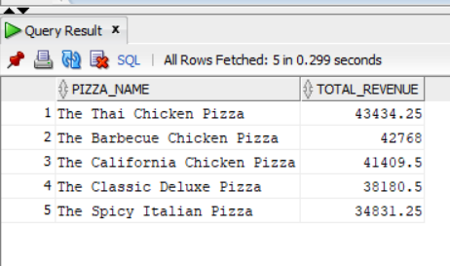
7.Bottom 5 Pizzas by Revenue
select * from
( select pizza_name,sum(total_price) as Total_Revenue
from pizza_sales
group by pizza_name
order by Total_Revenue asc)
where rownum<=5;
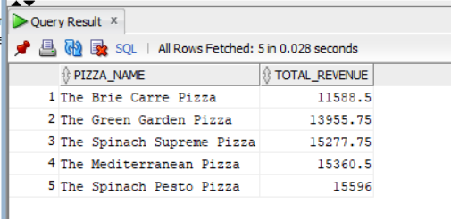

8.Top 5 Pizzas by Quantity
select * from
( select pizza_name,sum(quantity) as Total_Pizza_Sold
from pizza_sales
group by pizza_name
order by Total_Pizza_Sold desc)
where rownum<=5;
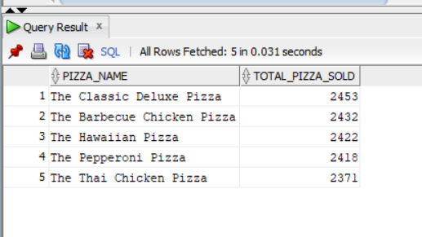

9.Bottom 5 Pizza by Quantity
select * from
( select pizza_name,sum(quantity) as Total_Pizza_Sold
from pizza_sales
group by pizza_name
order by Total_Pizza_Sold asc)
where rownum<=5;

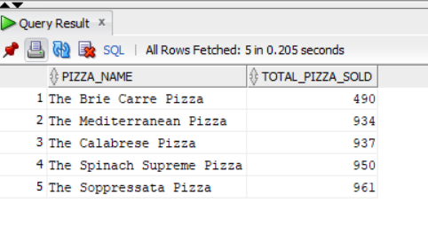
10.Top 5 Pizzas by Total Orders:

select * from
( select pizza_name,count(distinct order_id) as Total_Orders
from pizza_sales
group by pizza_name
order by Total_Orders desc)
where rownum<=5;

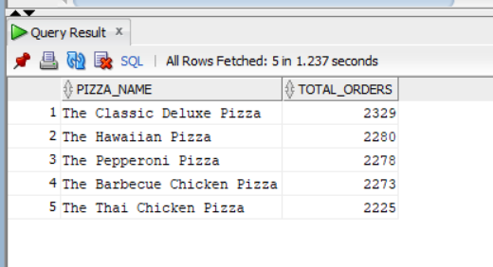
11. Bottom 5 Pizzas by Total Orders:

select * from
( select pizza_name,count(distinct order_id) as Total_Orders
from pizza_sales
group by pizza_name
order by Total_Orders asc)
where rownum<=5;
